Level 1 Solution IP Support Document

Table of Contents
Solution IP Overview 3
Connecting to the Solution IP 3
Guest Control 4
Add a User 4
Delete a User Account 5
Change a User from a Private IP to a Public IP 5
E-Mail limiting 6

Solution IP Overview

The Solution IP is a stand alone, high performance networking device designed for developing large scale, intelligent Public-access.

Connecting to the Solution IP

To connect to the Solution IP with a web browser, the URL is http://<IP address of Solution IP>. An example would be http://12.159.210.2.

After connecting to the page, you have to login with a username and password. After logging in, you should receive the following screen.
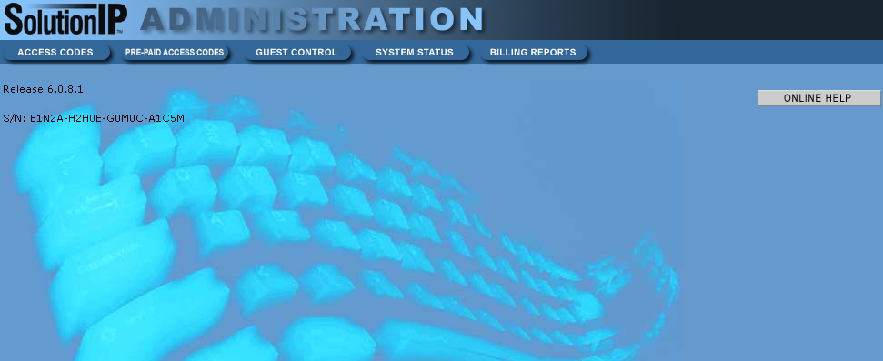

Guest Control

This section allows you to view current subscribers and inactive subscribers.

Add a User

Sometimes you may need to add a user manually to get them connected. I.E. If the user has a VPN client and has to connect to their VPN before they can get to the internet or some Macintosh PCs require you to manually add them.

Select Guest Control. You should receive a screen similar to below:

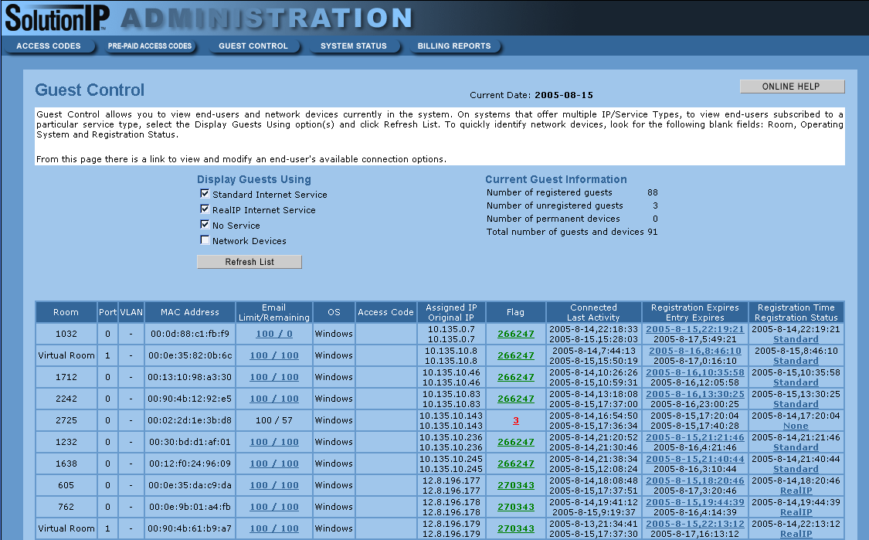

Search for the guests MAC address or IP address in the list. Click on the Registration Time/Registration Status link to change their access.
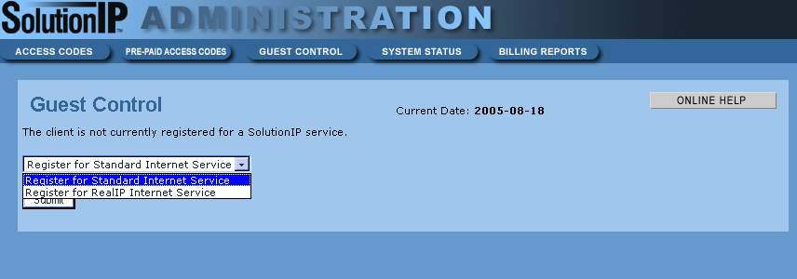

You will get the option to register/unregister them for Standard Internet Access/Real IP Internet Access. Set them up with Standard Internet Access unless then need access to a VPN.

Delete a User Account

Follow the procedure above and unregister the account.

Change a User from a Private IP to a Public IP

Follow the directions above to choose the Real IP option.

E-Mail limiting

Email Limit/Remaining column lists how many e-mails the guest is allowed to send (usually 100) and how many emails remaining. If someone was able to send mail previously and now can’t they may have reached the 100 email limit.

